

**CDAGeoV3TM**

**Software Operating Manual**

**Version 0.1**

**Date 18/10/2021**

Add device picture if applicable

Document Changes

|  |  |  |
| --- | --- | --- |
| ***Version*** | ***Date*** | ***Changes*** |
| 0.1 | 18/10/2021 | First Draft |
|  |  |  |
|  |  |  |
|  |  |  |
|  |  |  |
|  |  |  |
|  |  |  |
|  |  |  |
|  |  |  |
|  |  |  |
|  |  |  |
|  |  |  |
|  |  |  |

Table of Contents

1 Introduction 5

2 Starting Screen 5

2.1 Starting the Software 5

2.2 Selecting a Run 5

2.3 Changing Process Duration 6

2.4 Filtering a Run 6

2.5 Identifying Alarms 7

3 Geometry Analysis 7

3.1 Load and Display Geometry Data 7

3.2 Layer and Diameter Controls 8

3.2.1 Layer Controls 9

3.2.2 Diameter Controls 9

3.2.3 Toggling Alarms 10

3.3 Tooltip & Status Bar 10

3.4 Export Charts 11

3.4.1 Export Options 11

3.4.2 Export Path 11

3.4.3 Exported Data Format 12

3.5 Charting 12

3.5.1 Chart Types 12

3.5.2 Chart Thresholds 12

3.5.3 Editing Thresholds 13

3.5.4 Layers 13

3.5.5 Diameters 14

3.5.6 Chart Manipulation 15

3.6 Alarms 15

4 Further Analysis 15

4.1 Opening a B-Scan 16

4.2 B-Scan View 17

4.2.1 B-Scan Layers 17

4.2.2 Intensity 18

4.2.3 Reel Position and Radial Measurements 18

4.2.4 Alarm Markers 18

4.3 Controls Menu 19

4.3.1 Switching Channels 19

4.3.2 Show Filtered Data 20

4.3.3 Show Tracks 20

4.3.4 Alarm Channels 21

4.3.5 Minimise/Maximise 21

4.3.6 Admin Controls 21

4.4 Side Bar 22

4.4.1 Expand Channels 22

4.4.2 Radial Cursor 23

4.4.3 Custom Markers 23

4.4.4 Undo Marker 24

4.4.5 Clear Markers 24

# Introduction

This document provides instructions for the operation of the new CDA (Cable Data Analysis) software.

The primary purpose of the CDA is to analyse data captured by the UltraScreen system, for analysis both during and after the manufacturing process. The software provides a variety of data such as cable geometry and information for any detected flaws in the cable.

# Starting Screen

## Starting the Software

Double click the CDAGeoV3 desktop shortcut to start the software. The software will take a couple of seconds to launch.

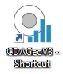

Once the software has loaded, the main form will appear.

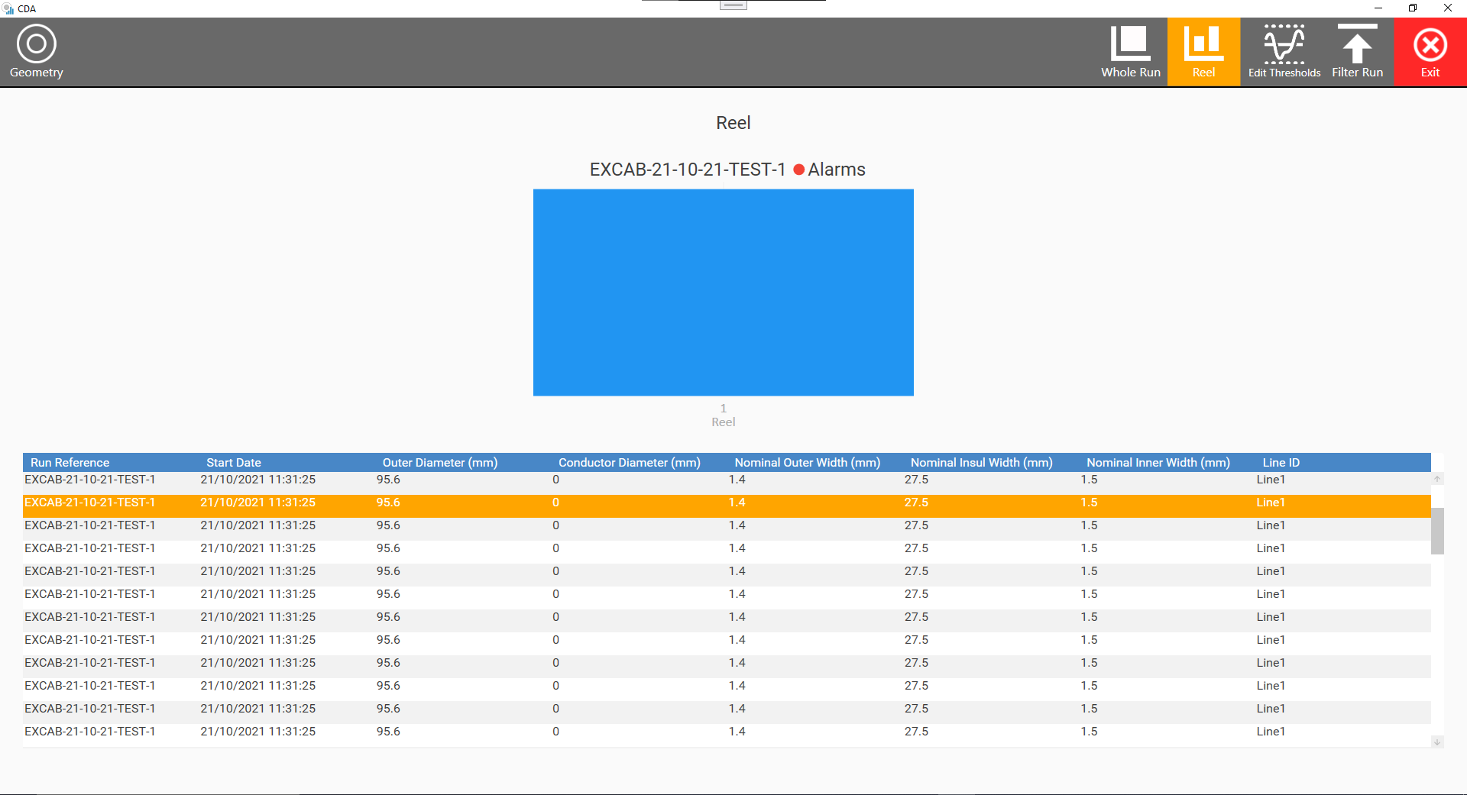

## Changing the Runs Folder Location

To update the runs folder location, press the ‘Settings’ button at the top of the display.

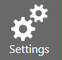

Displayed is the current directory for the runs folder.

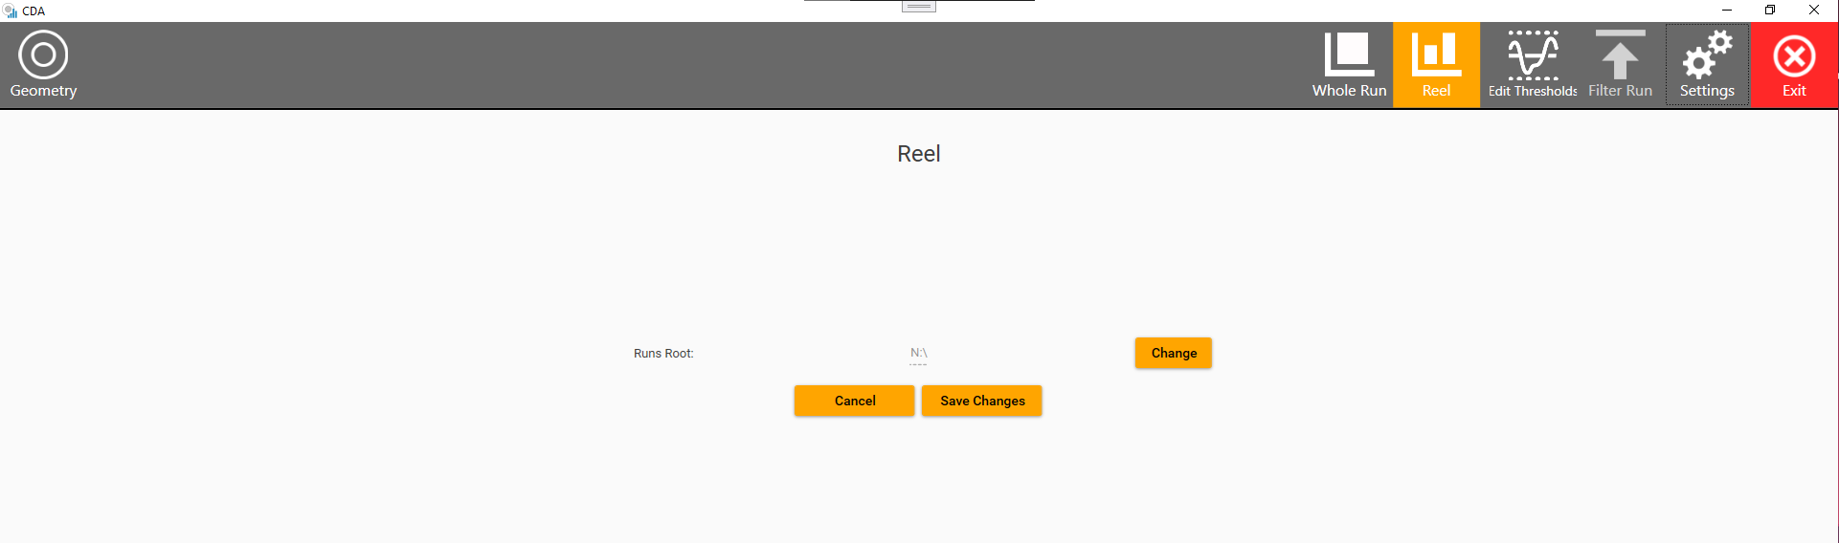

The UltraScreen runs directory can be changed by selecting the ‘Change’ button. Select the root directory where the UltraScreen runs are stored.

## Selecting a Run

Runs can be analysed by being selected from the runs table. The selected run is highlighted in orange. This is also where a summary of the cable recipe can be found, displaying the nominal layer measurements.

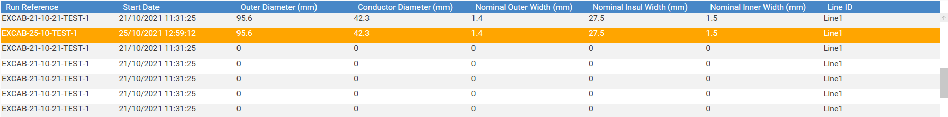

Once selected, the chart is updated with the individual reel data.

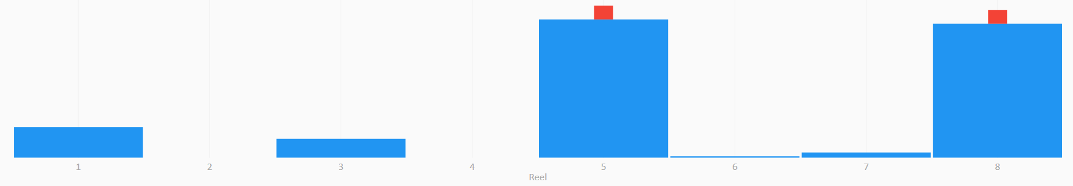

## Changing Process Duration

To analyse individual reels or the entire run, the process duration can be changed by toggling between the ‘Whole Run’ and the ‘Reel’ button, located at the top right hand side of the screen.

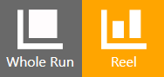

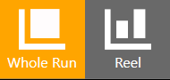

## Filtering a Run

Filtering a run is a process usually undertaken when an older run is occupying unnecessary space on the hard drive. Filtering the run will delete the raw and track files, which will typically occupy gigabytes.

Note: Once filtered, the majority of the run files are deleted permanently and the run can no longer be reprocessed.

To filter a run, click the ‘Filter Run’ button at the top-right hand corner.

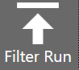

Otherwise, a Filter Run dialog window is opened.

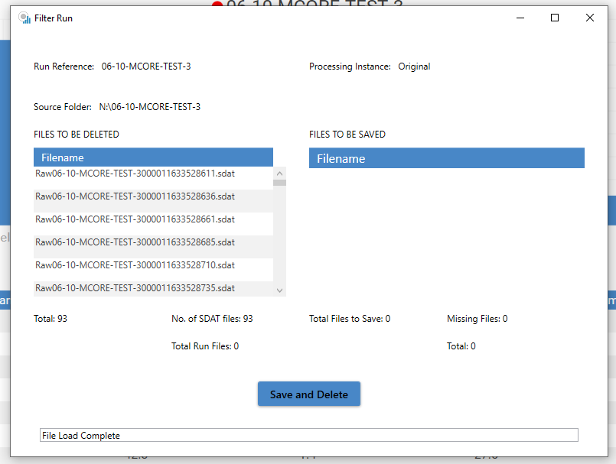

To Filter the run and delete the files, click the ‘Save and Delete’ Button.

## Identifying Alarms

Alarms are present on a specific reel when there is a small red square, located at the top of the reel. If there is no red square, there are no alarms for the reel.

Shown below is a full run demonstrating which reels have alarms present.

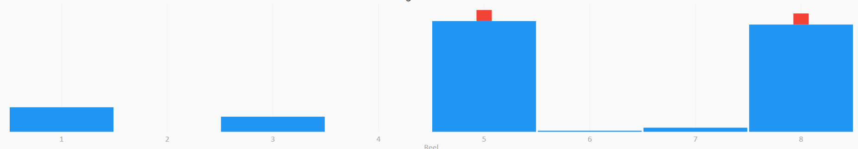

Full Run Showcasing Alarms

# Geometry Analysis

## Load and Display Geometry Data

To start analysing a run, firstly select a reel by selecting a chart column with the mouse. The selected reel will subsequently turn orange.

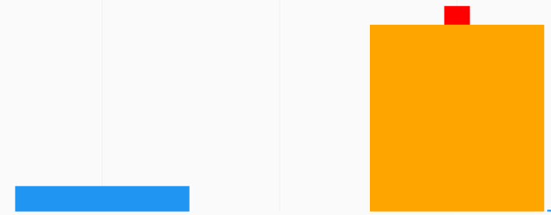

Next, select the ‘Geometry’ button located at the top-left corner.

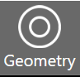

Once the geometry data has loaded, the geometry form will appear.

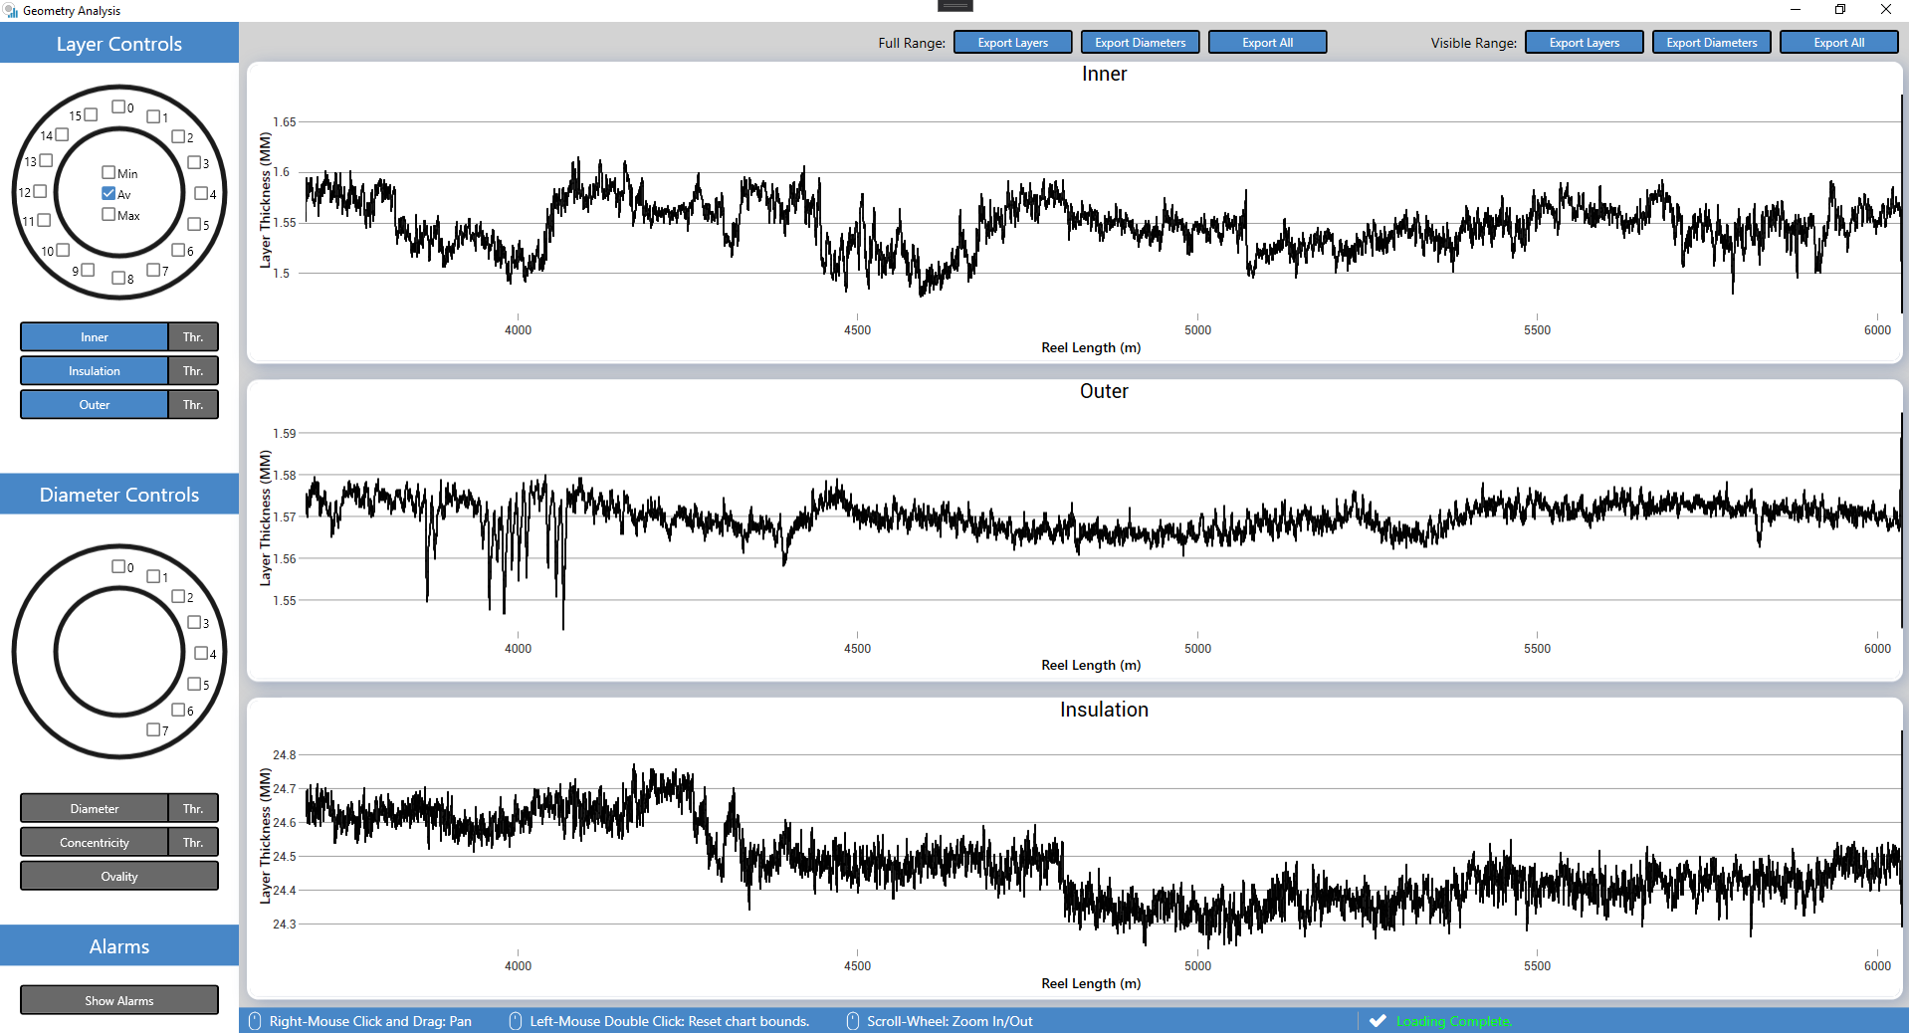

By default, the average value for Outer, Inner, and Insulation layer thicknesses are displayed.

## Layer and Diameter Controls

The contents of the charts are controlled entirely by the sidebar located on the left side of the window.

The sidebar can be compartmentalised into three individual sections, the layer controls, diameter controls, and the alarms.

### Layer Controls

Individual channels can be selected using the check boxes placed around the circle, which represents a cable and its respective channels. Selecting channels will plot the channel thicknesses to the charts.

The Average/Maximum/Minimum channel thicknesses can also be selected using the checkboxes in the centre of the cable. By default, only the average channel thicknesses are enabled.

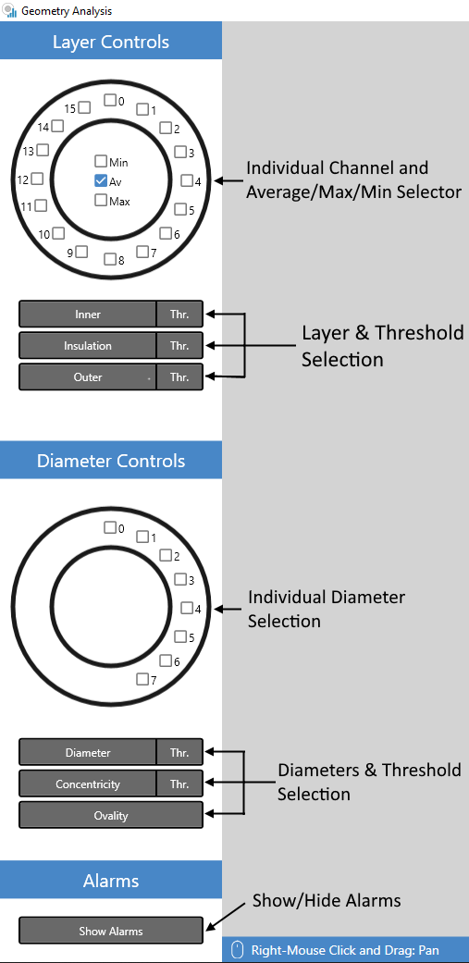

If a channel is enabled, the checkbox colour will match the colour of the plotted data on the charts.

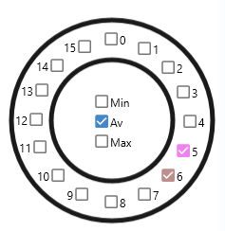

Channels 5,6 and average selected

The layer selection buttons are used to decide which layer charts are to be displayed on the screen, and the ‘*Thr.*’ buttons determine whether the layer thresholds for the specified layer are visible.

|  |  |
| --- | --- |
| C:\Users\44771\Desktop\Screenshot 2021-10-18 153130.png  Unselected Layers | Selected Layers |
|  |  |

### Diameter Controls

Individual diameters can be selected using the checkboxes placed around the circle.



Selecting a channel will display the geometry data for that specific diameter. This is represented by a line drawn between the two opposing channels.

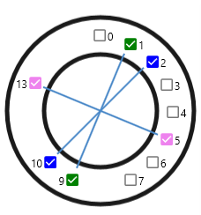

The diameter measurement charts can be enabled or disabled using the selection buttons.



### Toggling Alarms

Alarms can be turned on or off using the ‘Show Alarms’ button.



To view alarms, firstly it is important to have selected a reel or entire run which contains an alarm.

If any alarms have been detected on the reel, they are represented as a red dot located on the chart at the precise location along the cable that the alarm was identified.

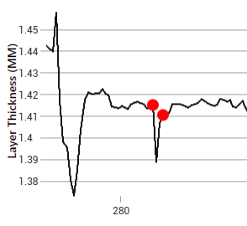

## Tooltip & Status Bar

Located at the bottom of the screen are tips for manipulating the charts with the mouse, and a status message.



The status message is located on the right side of the status bar. The status message will change depending on the status of the application.

For example, if the geometry data is loading, the status bar will be as shown below.



## Charting

On start-up, the Inner, Outer, and Insulation thickness charts are visible by default, and the series plot is the average channel thickness.

### Chart Types

The X Axis for the geometry charts differ, depending on whether an individual reel or the entire run is being analysed. When the entire run is being analysed, the X axis is a DateTime, spanning across the entire length of the run.

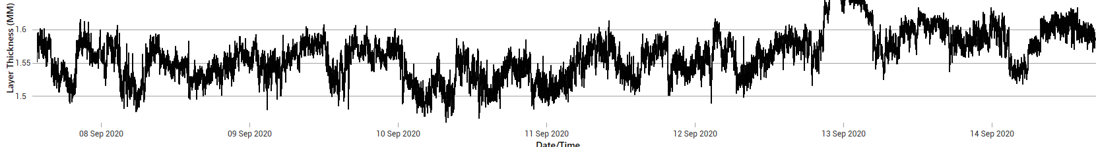

When viewing the whole run, red vertical lines spread across the chart are used to demonstrate where one reel ends and another begins.

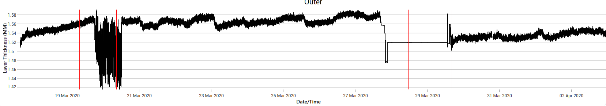

When an individual reel’s geometry is analysed, the X axis is the cable position, stretching across the length of the chosen reel.

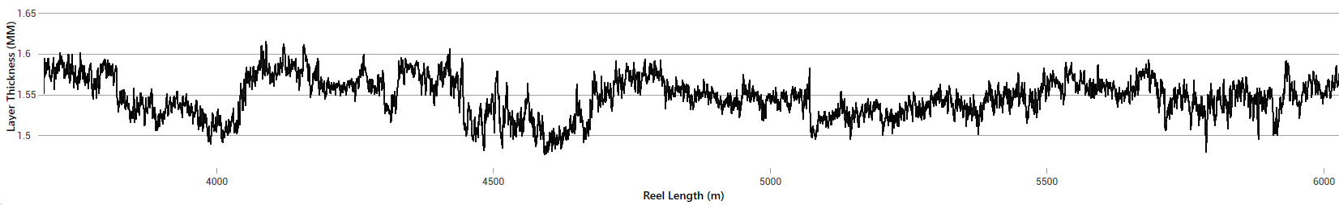

### Chart Manipulation

The charts are easily manipulated using a handful of mouse shortcuts, which can be seen in the ToolTip menu.

To pan the charts in any direction, move the mouse in the desired direction while holding down the right-mouse button.

To zoom in/out, use the mouse scroll wheel.

To Reset the chart boundaries, double click the chart.

Note: All charts x-axes are synchronous. When changing the axis limits on one chart, either by zooming or panning, the other charts will follow suit.

### Chart Thresholds

Chart thresholds can be enabled or disabled using the sidebar, explained in Section 3.2. When enabled, orange lines are used to represent the upper and lower thresholds, which are specified by the operator when starting a new run.

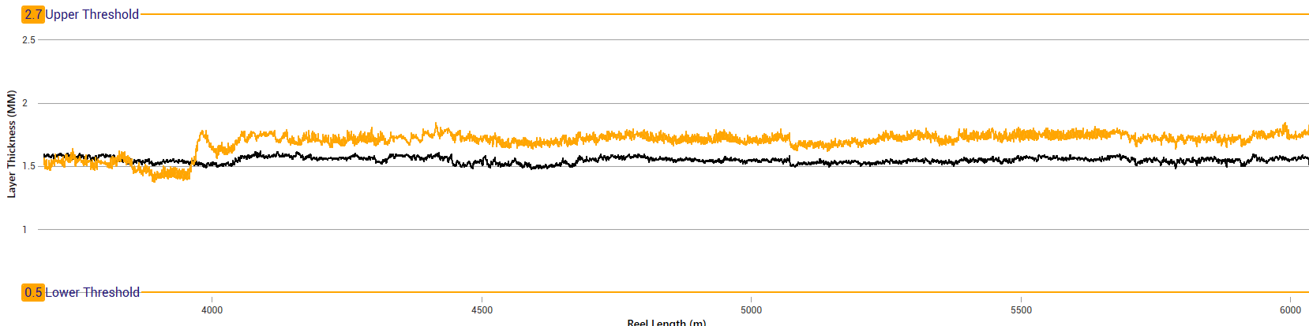

### Editing Thresholds

To edit thresholds for a run, firstly return to the startup screen, select the desired run, then click the “Edit Thresholds” button located at the top right hand side of the window.

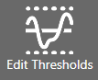

Once clicked, a new dialog window is displayed.

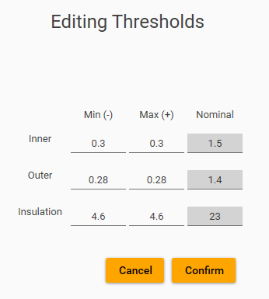

To change the thresholds, click on the textboxes, change the values, and press “Confirm”. Otherwise, press “Cancel”. Upon clicking “Confirm”, the thresholds will be updated in the database.

### Layers

The ‘Layers’ chart group includes Inner, Outer, and Insulation thickness plots. By default, all three layers are selected and visible to the user.

Shown below is the default start-up configuration, where the average Inner, Outer, and Insulation thicknesses are displayed.

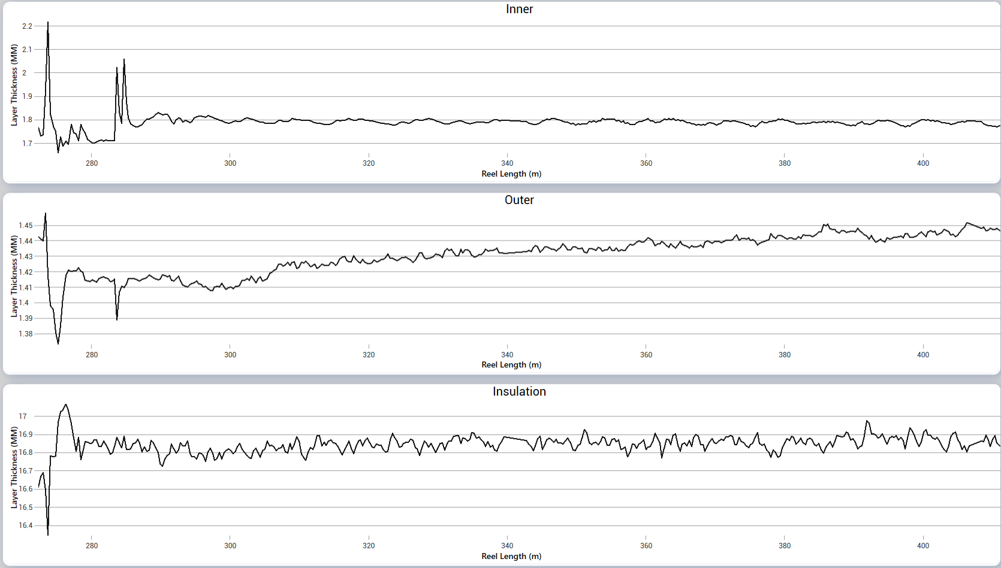

### Diameters

Various Diameter measurements are viewed by selecting from the Sidebar – see Section 3.2.2.

The Diameter chart plots the diameter of the cable across various channels – including average, maximum and minimum plots.

Shown below is the variation in the average cable diameter, over 10 meters of cable.

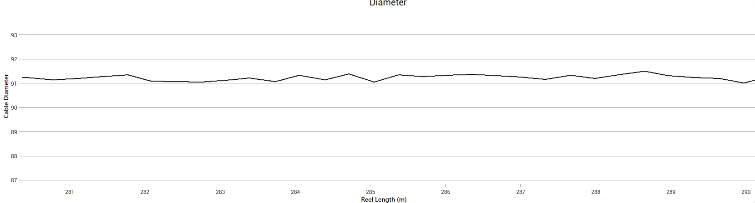

The concentricity chart values are defined by the formula:

$$Concentricity = \left(\frac{Tmax-Tmin}{Tmin}\right)* 100\%$$

Where $Tmax$ and $Tmin$ are the maximum and minimum insulation layer thickness.

And lastly, the ovality chart values are defined by the formula:

$$Ovality=\left( 1-\left(\frac{Dmax-DMin}{Dmax}\right)\right)*100\%$$

Where $DMax$ and $DMin$ are the maximum and minimum insulation layer diameters.

## Export Charts

The CDA provides the ability to export layer data to a CSV (comma separated value) format for both the entire run, or a user defined range.

Export chart buttons can be located at the top of the window.



### Export Options

Selecting a “Full Range” export option will export the entire range of date for the selected reel, and selecting a “Visible Range” option will only export the range of data which is visible on the charts.

“Export Layers” exports the Inner, Outer, and Insulation charts.

“Export Diameters” exports the Diameter, Concentricity, and Ovality charts.

“Export All” exports all of the above.

Furthermore, there is the option to export individual layers. This is achieved by right-clicking on the respective layer’s chart, hovering over “Export Data”, then selecting one of “Export Full Range” or “Export Visible Range”.

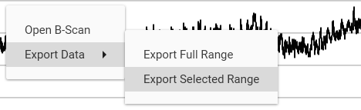

### Export Path

By default, the data is exported to the ‘Runs’ root folder. For example, if run data is located at “C:/Runs/”, the exported run data will be located at: “C:/Runs/{run reference}/Exports/{LayerExport}.csv”.

### Exported Data Format

The format for the exported data depends on which layer is being viewed. The following example showcases the default format for the Inner layer. The CSV file contains the date, cable positions, reel length, average thickness, and all the individual channel thicknesses.



# Further Analysis

In the instance that further analysis of an alarm or specific area of the cable is required, B-Scans are used for this purpose. A B-Scan is a visual representation of the cable at a specified point in the run.

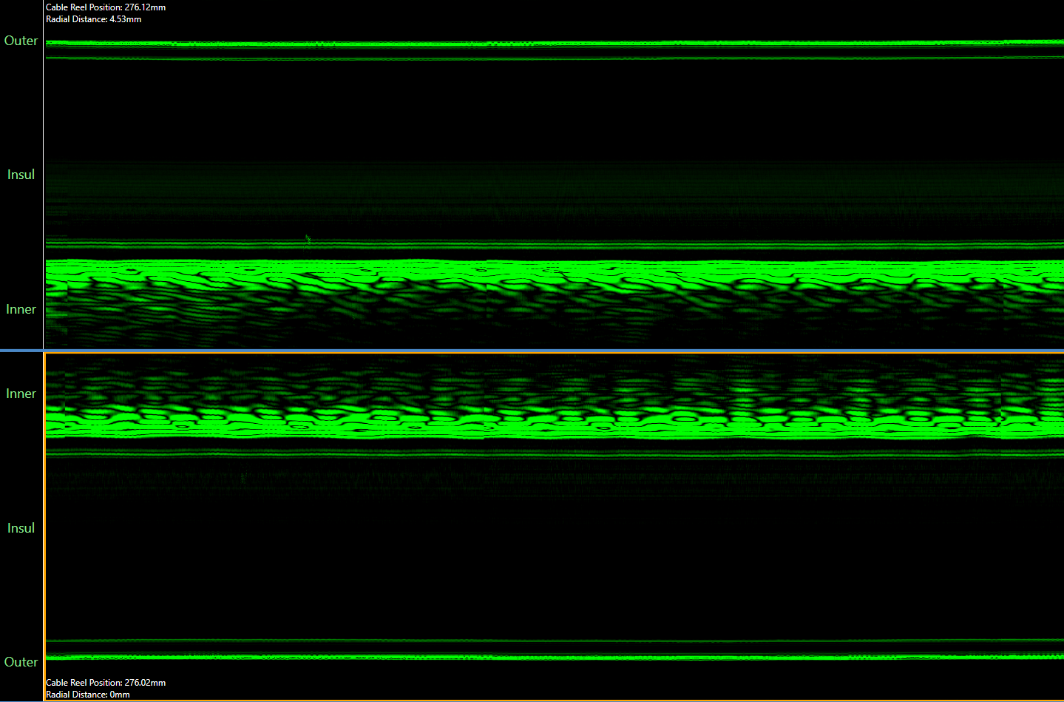

Note: If a run has been filtered, the only remaining B-Scans will be for features.

## Opening a B-Scan

To open a B-Scan, right click on a chart at any point, and select ‘Open B-Scan’.

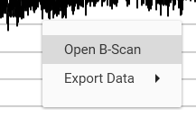

B-Scans will take a few seconds to load, however if connected via VPN this process can take up to a minute.

Once the B-Scan data has loaded, a new window will appear.

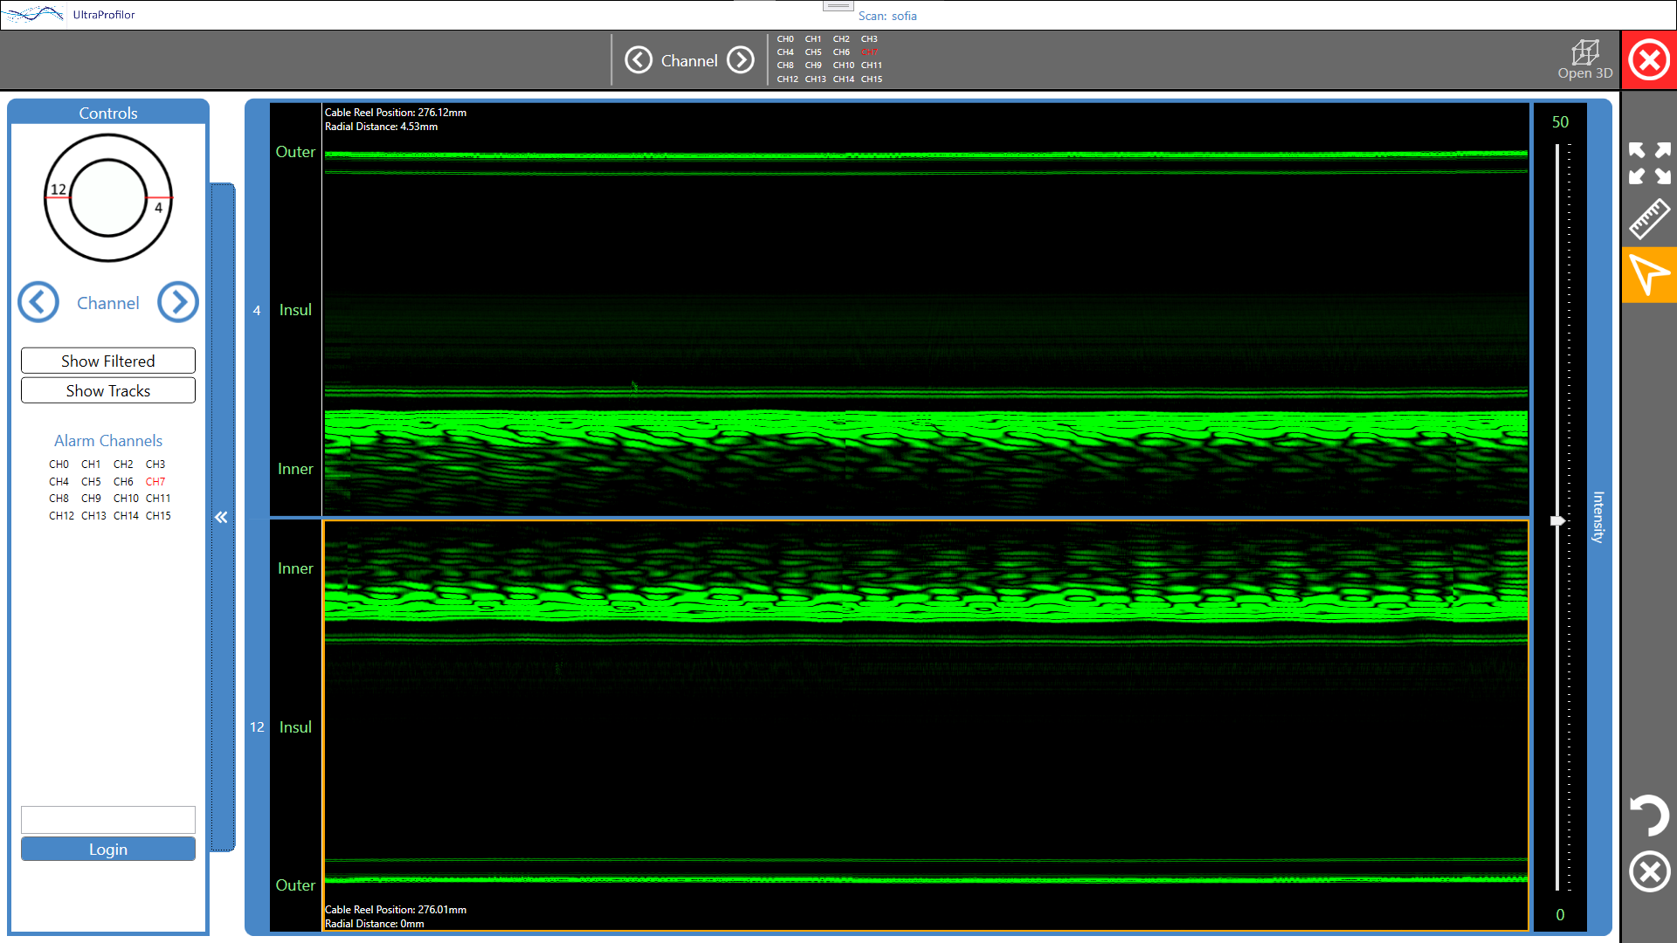

Note: If alarms are enabled on the charts, clicking the ‘Open B-Scan’ button will find the nearest alarm to the mouse cursor and open the B-Scan where the alarm is present. To open a B-Scan precisely where the mouse cursor is, ensure that the ‘Show Alarms’ toggle is disabled first.

## B-Scan View

The middle section of the main screen is the B-Scan view itself. By default, Channels 0 and 8 are visible, forming a full diameter cross-section view of the cable. The active channels can be seen on the blue handles on the left-hand side of the B-scan view.

## Controls Menu

The controls menu is located on the left hand-side of the window.

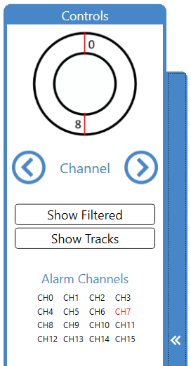

The circle is a representation of the cable and which channels are currently visible on the B-Scan view. By default, channels 0 and 8 are visible.

### Switching Channels

There are various options available when it comes to changing channels. The B-Scan channels are paired to ensure that both visible channels always form a cross-section of the cable, so Channels 0-8, 1-9, 2-10 e.t.c are paired together.

To rotate channels clockwise or anti-clockwise, click the buttons shown in Figure 46 (left arrow for anti-clockwise, right arrow for clockwise). Alternatively, there are buttons with the same functionality located on the grey bar at the top of the main window, shown in Figure 47.





Pressing one of these buttons will rotate the visible channels around the cable in the desired orientation. Furthermore, the cable representation will update to reflect which channels are being viewed.

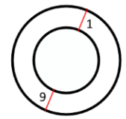

Note: It is not required to wait for a channel pair to load before rotating again to the next channel pair. There is a 1 second timer before the channel pairs load, so you can click as many times as necessary to get to the desired pair.

### Show Filtered Data

Filtered data can be viewed by pressing the ‘Show Filtered’ button.



Filtered data filters out the intensity of the normal B-Scan.

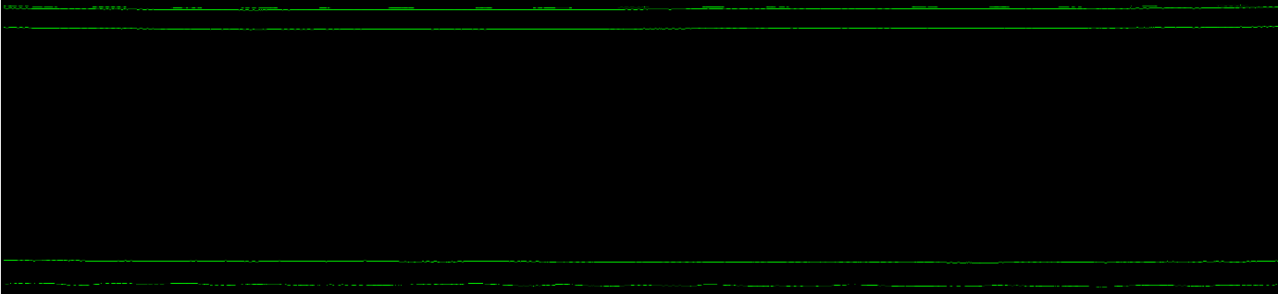

### Show Tracks

Tracks can be viewed by pressing the ‘Show Tracks’ button.



The tracks are shown on the B-Scans as blue lines, and represent the boundary intersections between the Inner, Outer, and Insulation Layers.

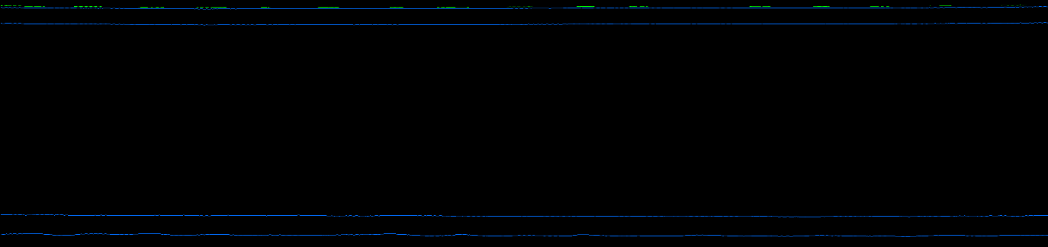

### Alarm Channels

If a B-Scan with alarms present is opened, there will be an ‘Alarm Channels’ grid.

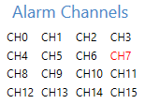

The values in the grid represent each channel of the cable – from 0 to 15. If a grid element is highlighted in red, there is an alarm present on this channel. Shown above, there is an alarm present on Channel 7. The alarm channels grid is also present on the grey bar at the top of the window.

### Minimise/Maximise

The Controls Menu visibility can be toggled. This can be useful if the user wants to enlarge the B-Scan view. To do this, use the large blue button on the right-hand side of the controls menu.

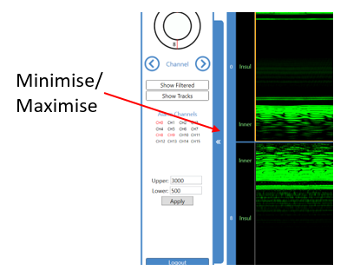

|  |  |
| --- | --- |
| Expanded View | Minimised View |

### B-Scan Layers

The green text on the left hand side showcases which layer is being inspected – for Inner, Outer, and Insulation.

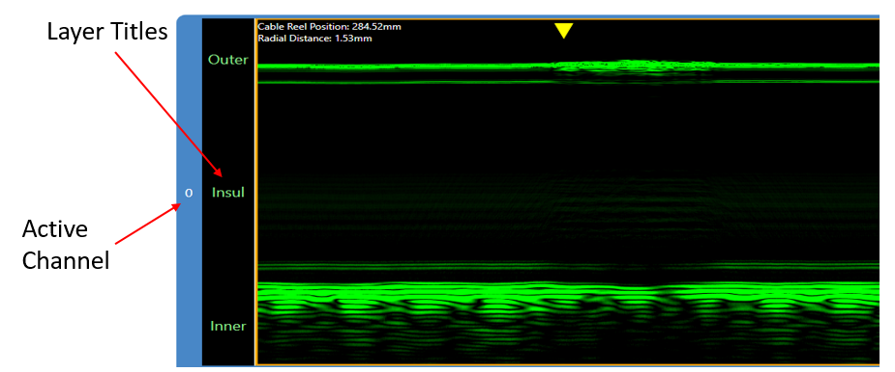

### Intensity

The B-Scan intensity can be changed using the slider on the right-hand side. This can sometimes be useful to identify abnormalities in the cable. Intensity is measured as a percentage value, from 0 to 100. By default, the intensity is set to 50%.

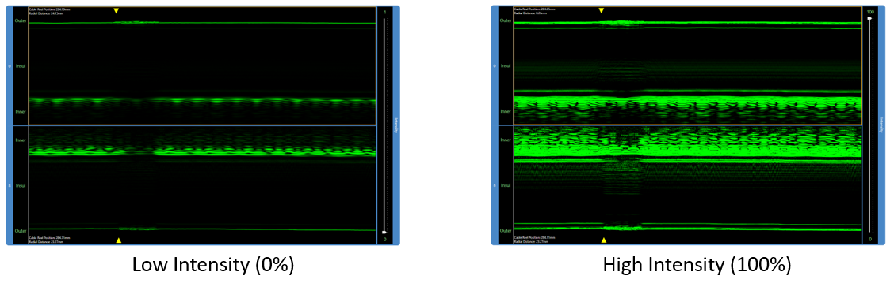

### Reel Position and Radial Measurements

Located in the top-left/bottom-left (depending on which channel) of the scan are two measurements, the ‘Cable Reel Position’ and the ‘Radial Distance’. Moving the mouse around the B-Scan will update these two measurements depending on the position of the mouse.

‘Cable Reel Position’ is the position of the cable being inspected.

‘Radial Distance’ measures the distance from the outer surface of the cable, to the current mouse position.

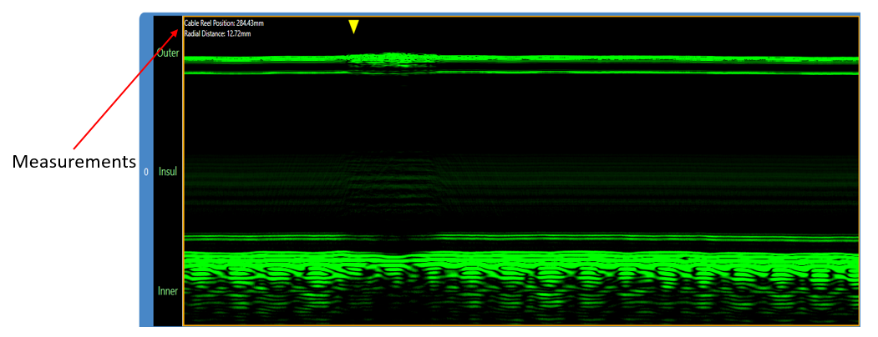

### Alarm Markers

If there is an alarm on one of the visible channels, it is represented as a small yellow triangle pointing out where the alarm was identified.

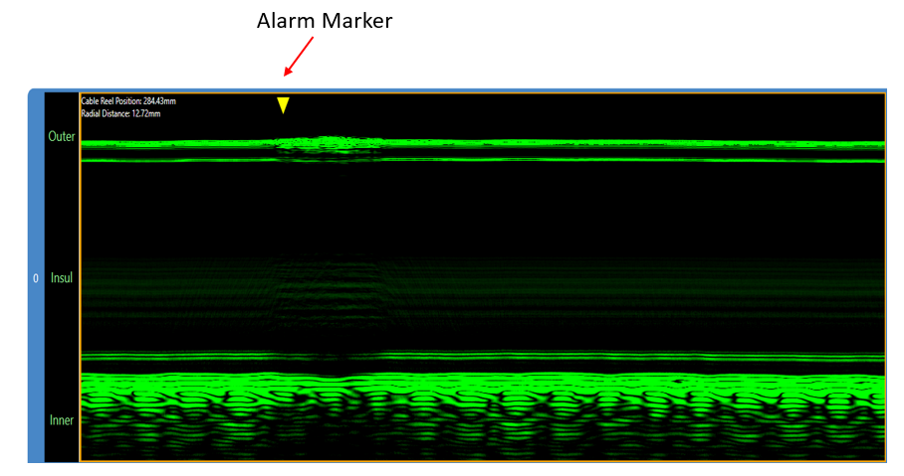

## Side Bar

The side on the right-hand side of the window contains a few useful controls.

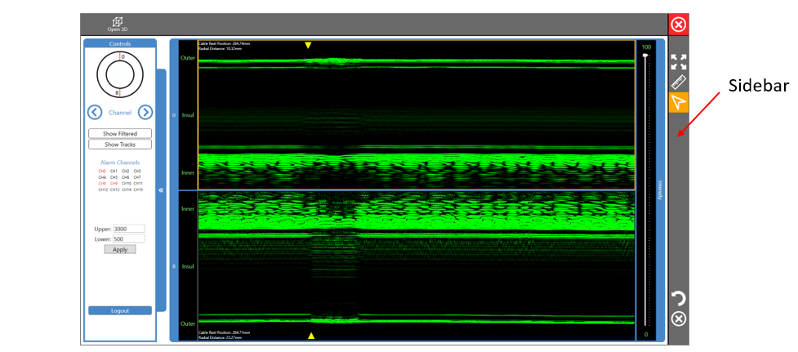

### Expand Channels

If the area of interest is in one particular channel, the channel can be expanded using the ‘Expand’ button, shown below.



Once pressed, the selected channel will be expanded to fill the vertical space of the screen.

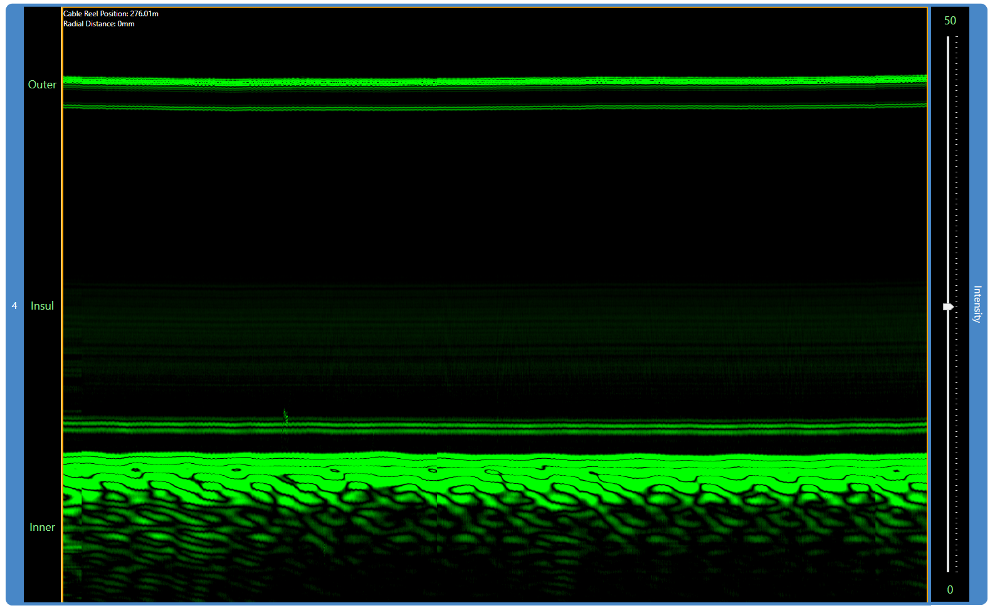

### Radial Cursor

The radial cursor is selected by default when the B-Scan window is opened. Alternatively, the radial cursor can be selected using the button shown below.



When clicking somewhere on the B-Scan with the radial cursor enabled, a vertical line or ‘Marker’ is drawn at the horizontal mouse position. The marker contains three distinct measurements, the Inner, Outer, and Insulation layer thicknesses.

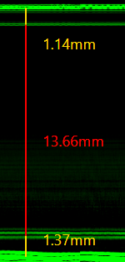

### Custom Markers

Alternatively, a custom cursor can be selected using the ruler button shown below.



With the custom markers selected, Clicking and dragging the mouse across the B-Scan will draw a white line across the B-Scan. Releasing the mouse button will end the line, and show the length of the marker.

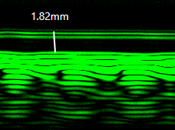

The user can draw as many custom markers as desired, and they can be drawn in any direction.

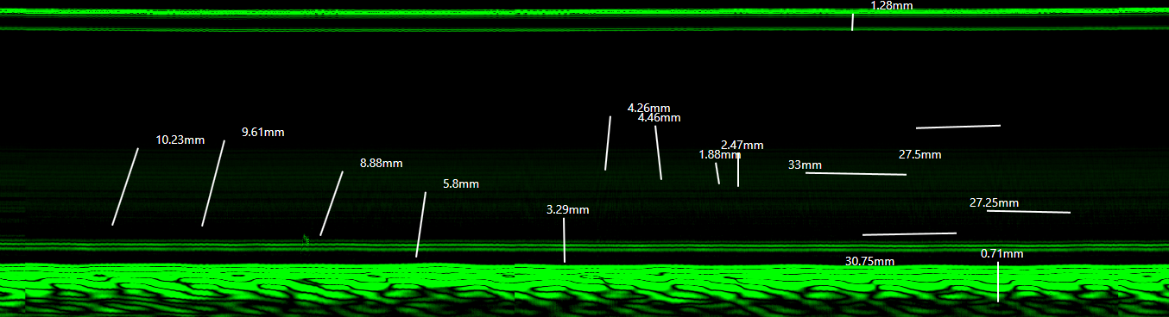

### Undo Marker

To undo the most recently drawn marker, use the button shown below.



### Clear Markers

Alternatively, you can remove all visible markers using the button shown below.



